

***School of Mechanical & Manufacturing Engineering (SMME),***

***National University of Science and Technology (NUST),***

***Sector H-12, Islamabad***

Program: BE-Aerospace Section: AE-01

Session: Fall 2023 Semester: 1st

Course Title: Fundamentals of Programming (CS-109)

**Lab Assignment**

***Name: Affan Suhail***

***CMS:*** 477560

Q1: Write a C++ program, take two strings as input from the user, and check if both strings

are equal or not. If they are equal make them unequal by rotating string. e.g., Hello

is turned into olleH, etc.

**Ans:**

**Code:**

#include <iostream>

#include <string>

#include <algorithm>

int main() {

std::string s1, s2;

std::cout << "Enter first string: (relation is case sensitive) ";

std::cin >> s1;

std::cout << "Enter second string: ";

std::cin >> s2;

if (s1==s2) {

reverse(s1.begin(), s1.end());

std::cout << "Strings were equal. Rotating first string: " << s1 << std::endl;

} else {

std::cout << "Strings are not equal." << std::endl;

}

return 0;

}

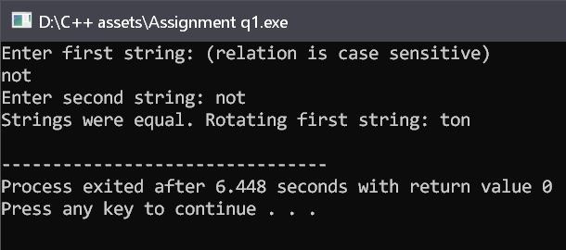

Q2: Write a C++ program for a string that may contain lowercase and uppercase characters. The task is to remove all duplicate characters from the string and find the resultant string.

**Ans:**

**Code:**

#include <iostream>

#include <string>

int main() {

std::string DS;

std::cout << "Enter a string: ";

std::getline(std::cin, DS);

std::string NS;

std::cout<<"result string test" <<NS;

for (char ch : DS)

{

bool dup = false;

for (char Ch : NS) {

if (ch == Ch) {

dup = true;

break;

}

}

if (!dup) {

NS.push_back(ch);

}

}

std::cout << "String after removing duplicates becomes: " << NS << std::endl;

return 0;

}

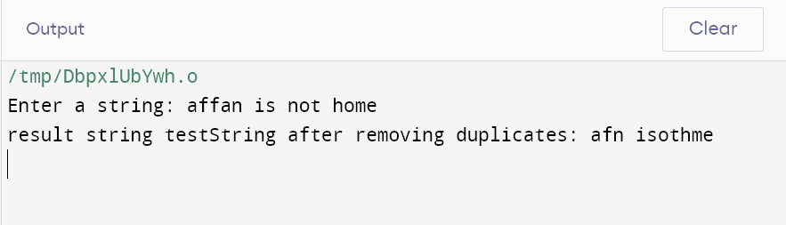

**Q3:** Suppose an integer array a[5] = {1,2,3,4,5}. Add more elements to it and display

them in C++.

**Ans:**

**Code:**

#include <iostream>

int main ()

{

int a[5]={1,2,3,4,5};

for(int k=0;k<5;k++)

std::cout<< a[k] <<"\t";

std::cout<< "\nthis is the default array for reference\n";

int p,n,c;

int t=0;

std::cout<<"Enter the integer element value to be added\n";

std::cin>>n;

std::cout<<"Enter the index location where you want this added\n";

std::cin>>p;

for(int i=4;i>=p;i--)

a[i+1]= a[i];

a[p]=n;

std::cout<< "The array after updating element is displayed as\n";

if(p>5)

{

for(int j=0;j<=p;j++)

std::cout<< a[j] <<"\t";

}

else

for (int j=0;j<6;j++)

std::cout<< a[j] <<"\t";

std::cout<<"\n(any random numbers between allotted numbers are garbage values and should be ignored)";

return 0;

}

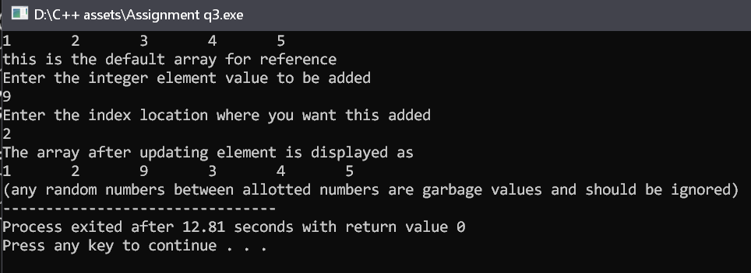

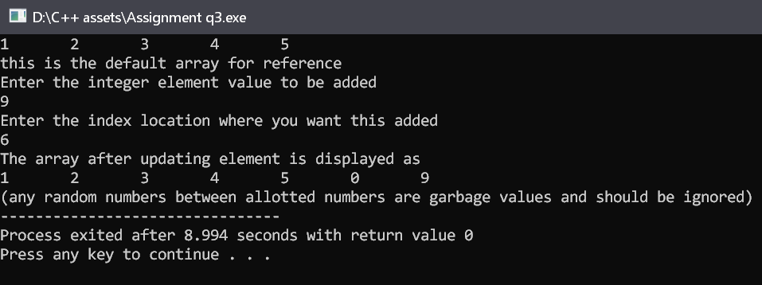

**Q4:** Write a C++ program that uses a while loop to find the largest prime number less

than a given positive integer N. Your program should take the value of N as input

from the user and then find the largest prime number less than or equal to N. You

are not allowed to use any library or pre-existing functions to check for prime

numbers.

**Ans:**

**Code:**

#include <iostream>

int main()

{

int N,p,t,r;

std::cout<<"Enter any number to find the nearest prime number to it.(prime number will be less than the number)\n";

std::cin>>N;

for(p=2;p<N-1; ++p)

{

for (t=2;t<p-1;t++)

{

if (p%t==0)

break;

}

if (p%t==0)

continue;

r=p;

}

std::cout<< r;

return 0;

}

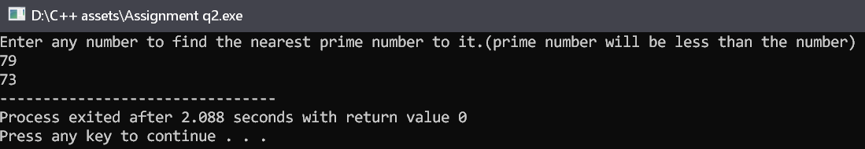

**Q5:** Implement Bubble Sort on an array of 6 integers.

**Ans:**

**Code:**

#include<iostream>

#include <climits>

void pa (int a[], int x) // i am creating a new function as a learning practice

{

for (int i=0;i<x;i++)

{ int c= a[i];

std::cout<< c <<"\t";}

}

int main()

{

int a[10] = {5,19,15,17,99,77};

std::cout<<"\n the original array will be displayed as \n";

pa (a,6);

int t = INT_MIN;

for(int j=0; j<6; j++)

{

t= std::max (t,a[j]);

for (int k=0; k<6; k++)

{if (a[j]> a[k])

std::swap (a[j], a[k]);

else

continue;}

}

std::cout<<"\nthe array in descending order will be displayed as \n";

pa (a,6);

return 0;

}

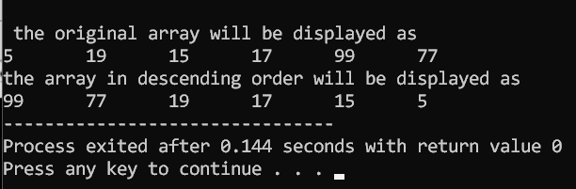

**Q6:** Solve any Aerospace/Real Life Problem using C++ Programming.

**Ans:**

We will solve an aerospace problem by helping the user to calculate either of Coefficient of drag, Coefficient of lift, or Coefficient of Pitching moment.

**Code:**

#include <iostream>

int main()

{ int choice;

float l,d,p,v,m,c,S,Cl,Cd,Cm;

std::cout<< "enter\n1 for determining Coeffecient of lift\n2 for determining Coeffecient of Drag\n3 for determining Coeffecient of Pitching moment\n";

std::cin>> choice;

switch(choice)

{

case 1:

{

std::cout<<"\nEnter the lift force\t";

std::cin>>l;

std::cout<<"\nEnter the Fluid density\t";

std::cin>>p;

std::cout<<"\nEnter the velocity \t";

std::cin>>v;

std::cout<<"\nEnter the Area of the wing\t";

std::cin>>S;

Cl= l/((0.5)*p*(v*v)*S);

std::cout<<"\nThe coefficient of lift is\t" <<Cl;

break;

}

case 2:

{

std::cout<<"\nEnter the Drag force\t";

std::cin>>d;

std::cout<<"\nEnter the Fluid density\t";

std::cin>>p;

std::cout<<"\nEnter the velocity\t";

std::cin>>v;

std::cout<<"\nEnter the Area of the wing\t";

std::cin>>S;

Cd= d/((0.5)*p*(v*v)*S);

std::cout<<"\nThe coefficient of Drag is\t" <<Cd;

break;

}

case 3:

{

std::cout<<"\nEnter the Moment force\t";

std::cin>>m;

std::cout<<"\nEnter the Fuid density\t";

std::cin>>p;

std::cout<<"\nEnter the velocity\t";

std::cin>>v;

std::cout<<"\nEnter the Area of the wing\t";

std::cin>>S;

std::cout<<"\nEnter the Length of the Chord\t";

std::cin>>c;

Cm= m/((0.5)*p*(v*v)*S*c);

std::cout<<"\nThe coefficient of Pitching moment is\t" <<Cm;

break;

}

default:

{

std::cout<<"\nInvalid value";

break;

}

}

}

